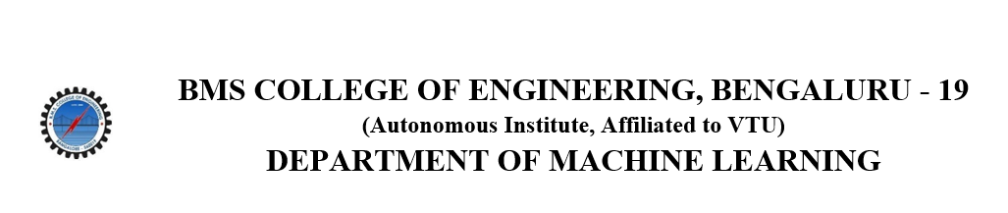
ACTIVITY REPORT
ON
Jumble Jam 2.0
- Name of the Club: BMSCE ACM STUDENT CHAPTER
- Name of the Activity: Jumble Jam 2.0
- Objectives: The BMSCE ACM Student Chapter in collaboration with BMSCE IEEE WIE organized a fun infused technical event named “Jumble Jam 2.0”. This event aimed to foster teamwork, bringing out creativity among peers, and promote competitive programming among participants.
- Date, Time Venue of the Activity:
EVENT | Jumble Jam 2.0
DATE/DAY | Monday, 28th October 2024
TIME | 11:00 am to 1:00 pm
VENUE | PJA Block, 6th floor, Computer Science Data Science Lab
- Name and details of collaborating agency (if it is collaborative/joint activity): BMSCE IEEE WIE
- Brief summary of the Event:
The "Jumble Jam 2.0" competition, organized by the BMSCE ACM Student Chapter in collaboration with BMSCE IEEE WIE, was a fun and challenging event held on October 28, 2023. It consisted of three rounds, each designed to test participants' knowledge, technical skills, and teamwork.
- Round 1: Quiz Round
In this initial round, teams of two tackled 20 questions displayed on the screen. Answers were written on sheets provided to each team. This round tested participants' knowledge on a variety of subjects, setting the tone for the competition.
- Round 2: Tech and Fun
Teams were divided into two roles: one teammate solved technical questions while the other played online games. This round combined technical problem-solving with lighthearted gameplay, adding a unique twist. Participants earned letters from their performance in this round, which would be used later.
- Round 3: Unscramble
In the final round, teammates reunited to use the letters they had earned in previous rounds. Together, they worked to unscramble a 9-letter word, relying on collaboration and logical deduction to solve the puzzle.
The event encouraged participants to think critically, work together effectively, and enjoy a mix of technical and entertaining activities. The team with the highest score at the end of all three rounds was declared the winner.
- Outcomes: "Jumble Jam 2.0" provided an excellent opportunity for participants to practice problem-solving, teamwork, and creative thinking in a supportive and engaging environment. The varied rounds ensured that each team member could contribute their strengths, promoting a collaborative spirit among participants.
- Number of participants:
Number of teams | Number of participants
27 | 54

- Photographs of the event:

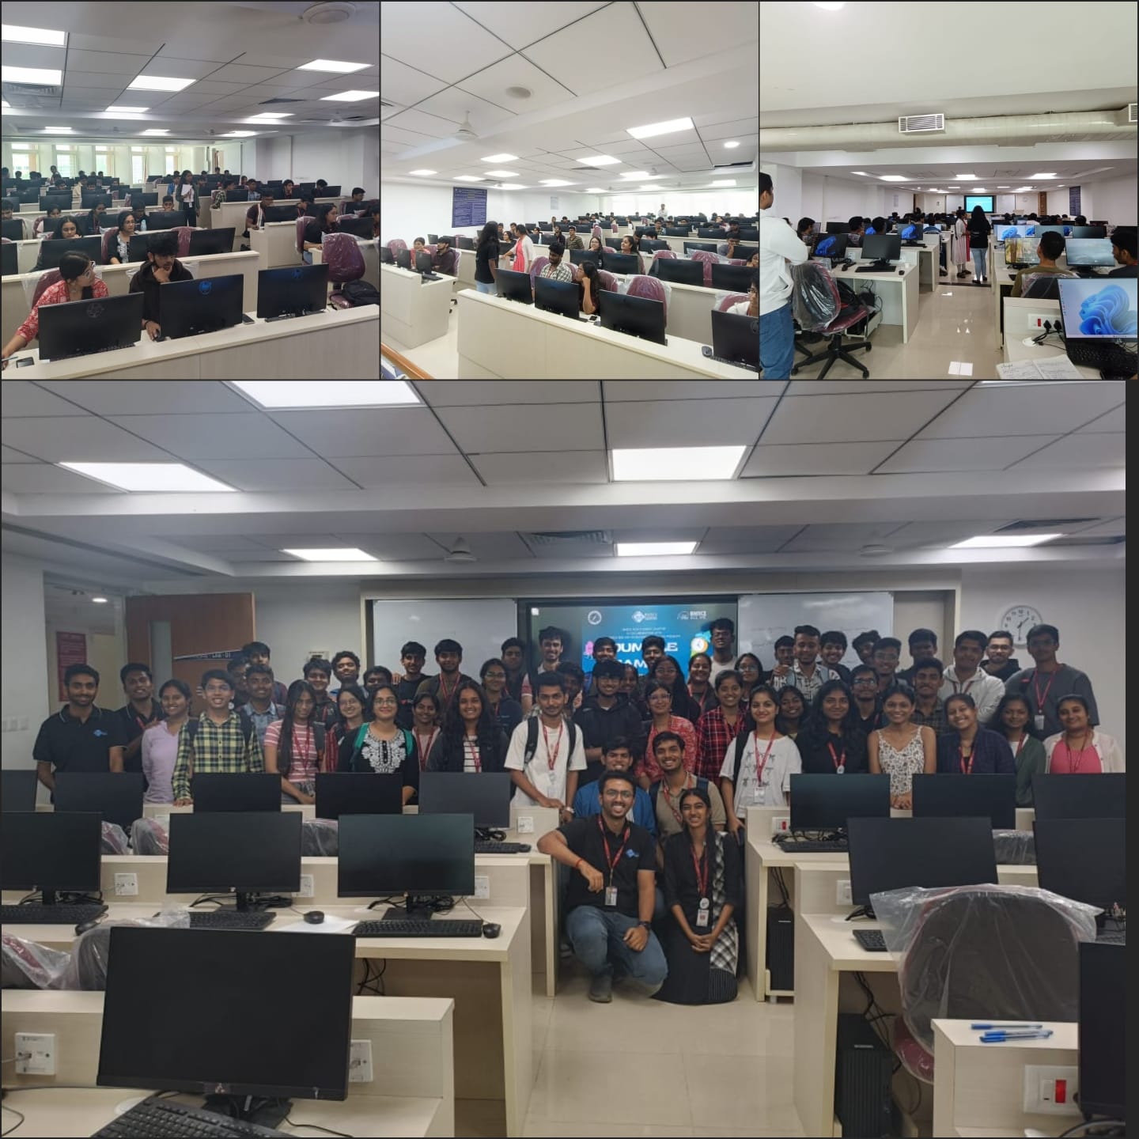

- Supporting Documents:
- Circulars/Brochures:

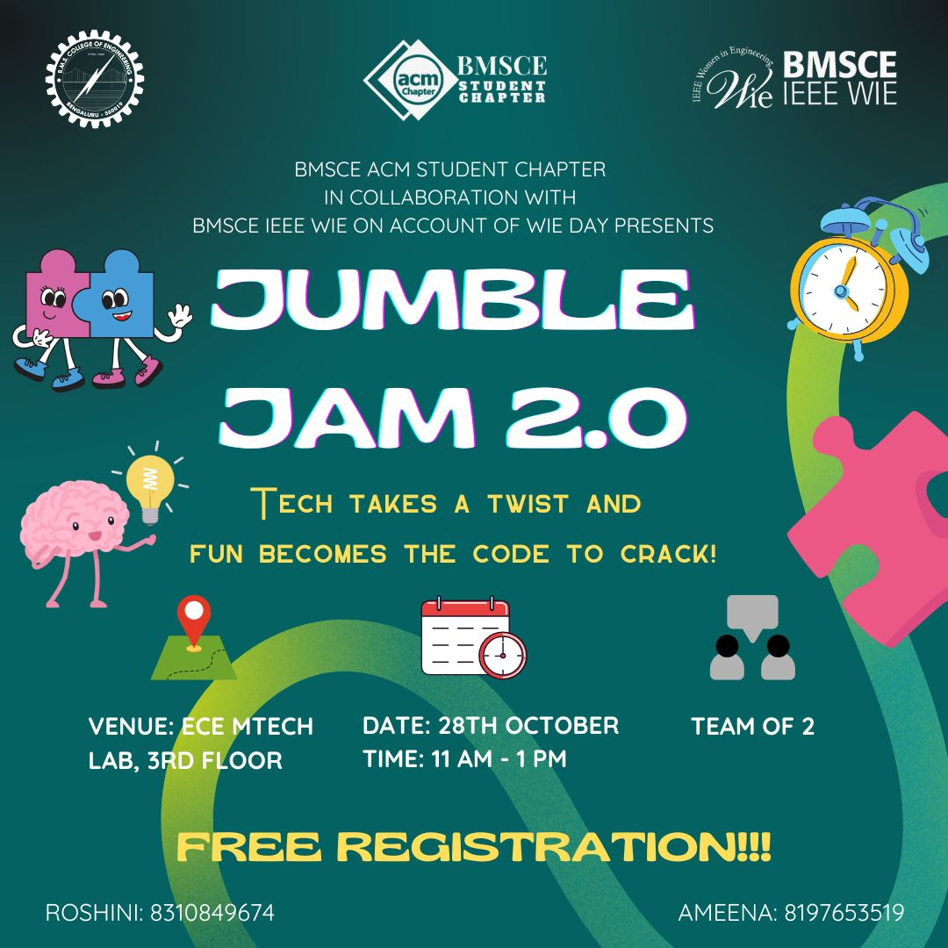
- Certificates:

